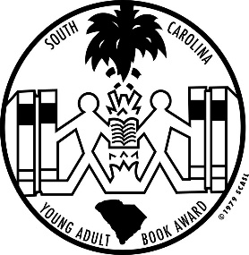

***South Carolina***

***Young Adult Book Award Nominees***

***2019 - 2020***

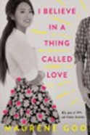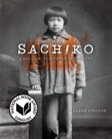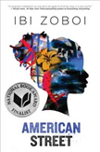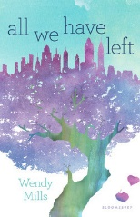

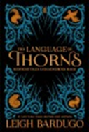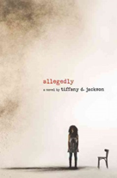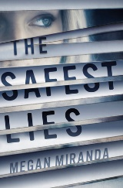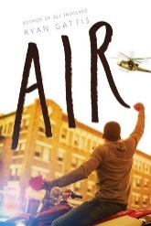

***Alegedly: a novel* by Tiffany D. Jackson**

***American Street* by Ibi Zoboi**

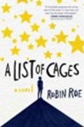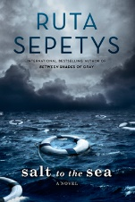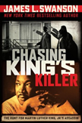***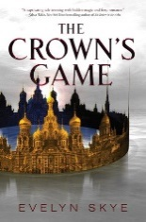Chasing King’s Killer: The Hunt forMartin Luther King Jr.’s Assassin* by James L. Swanson**

***Deacon Locke Went to Prom* by Brian Katcher**

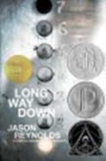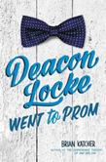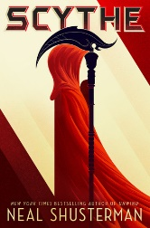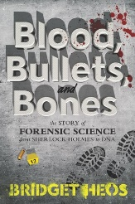***Dear Martin* by Nic Stone**

***Dreamland Burning* by Jennifer Lathan**

***Everything All At Once* by Katrina Leno**

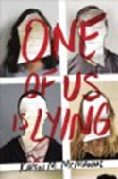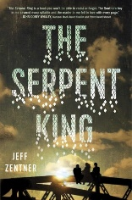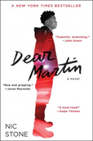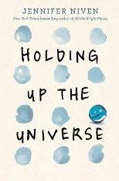***Far From the Tree* by Robin Benway**

***Glow* by Megan E. Bryant**

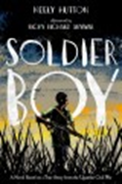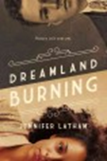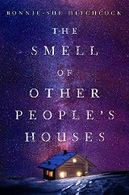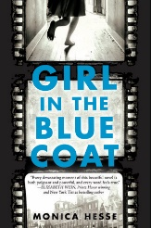***Grit* byGillian French**

***I Believe in a Thing Called Love* by Maurene Goo**

***The Language of Thorns: Midnight Talesand Dangerous Magic* by Leigh Bardugo**

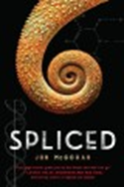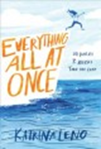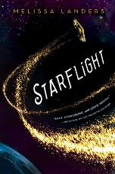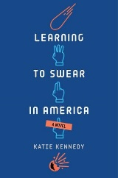***A List of Cages: a novel* by Robin Roe**

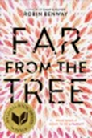***Long Way Down* by Jason Reynolds**

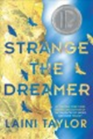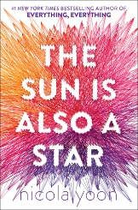***One of Us is Lying* by Karen M. McManus**

***Soldier Boy* by Keely Hutton**

***Spliced* by Jon McGoran**

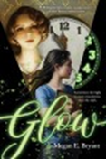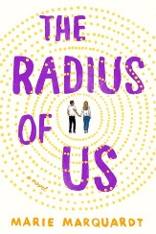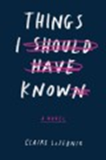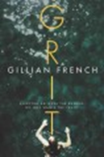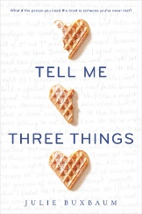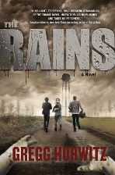***Strange the Dreamer* by Laini Taylor**

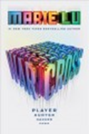*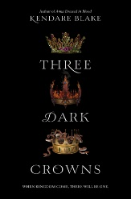****Things I Should Have Known* by Claire LaZebnik**

***Warcross* by Marie Lu**

**South Carolina Association of School Librarians**

PO Box 2442, Columbia, SC 29202

**Students:** To be eligible to vote for your favorite book, you must read at least **three** of the nominee titles. Voting takes place in early February.

For more information about the SC Young Adult Book Awards program, see a library staff member.

Book images courtesy of Novelist Plus database: www.scdiscus.org.

All media specialists should review all titles and add them to their collection only if the titles meet the criteria established by District Board Policy and Library Media Center Policy & Procedure guidelines. We recommend that others interested in purchasing these titles read reviews and scan materials to determine the appropriateness for their intended readers.